Copyright for test papers and marking guides remains with West Australian Test Papers.
Test papers may only be reproduced within the purchasing school according to the advertised Conditions of Sale.
Test papers should be withdrawn after use and stored securely in the school until Wednesday 10th October 2018.



SEMESTER TWO

MATHEMATICS
SPECIALIST
UNITS 3 & 4

2018

SOLUTIONS

Calculator−free Solutions

1. (a) (The two planes are parallel.) (1)

(b)

(4)
2. (a)
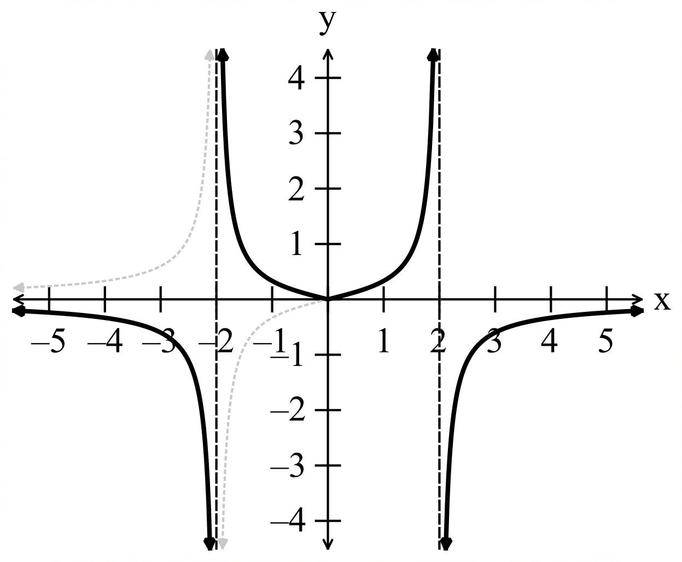
-1/error

(2)
(b)
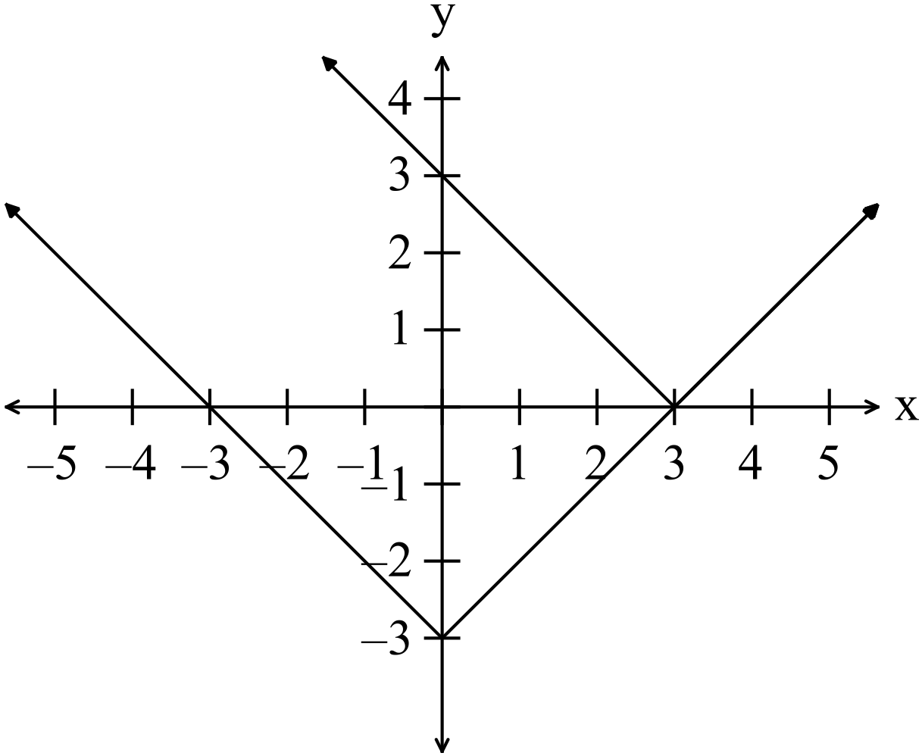

i.e. (3)

OR algebraically

2. (b)

3. (a) (i) and

(3 )

(ii)
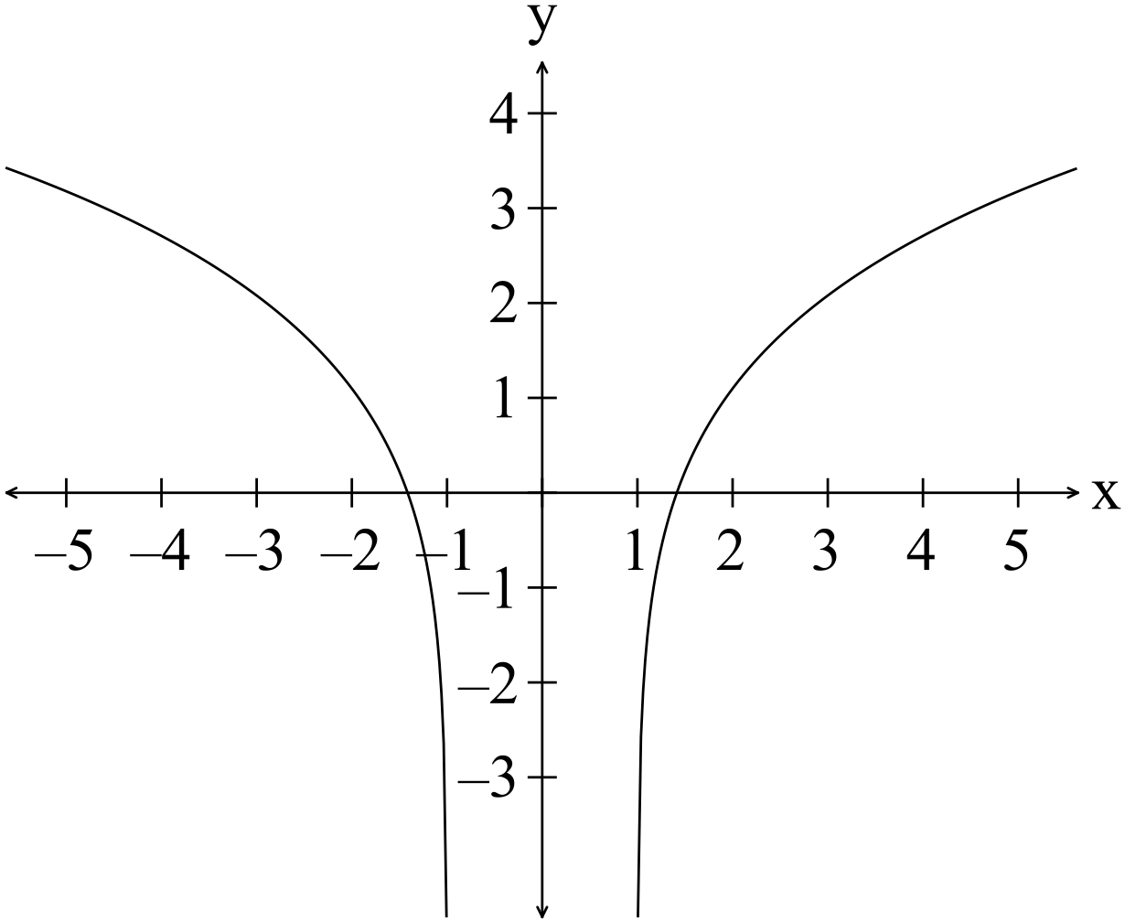

Not one to one as i,e,

A one to one function has a unique y value for very x value and vice versa.
(2)

(b)
To obtain the inverse:

Accept either solution. (3)

4. (a)

(1)
(b)

(4)

(c) (i)
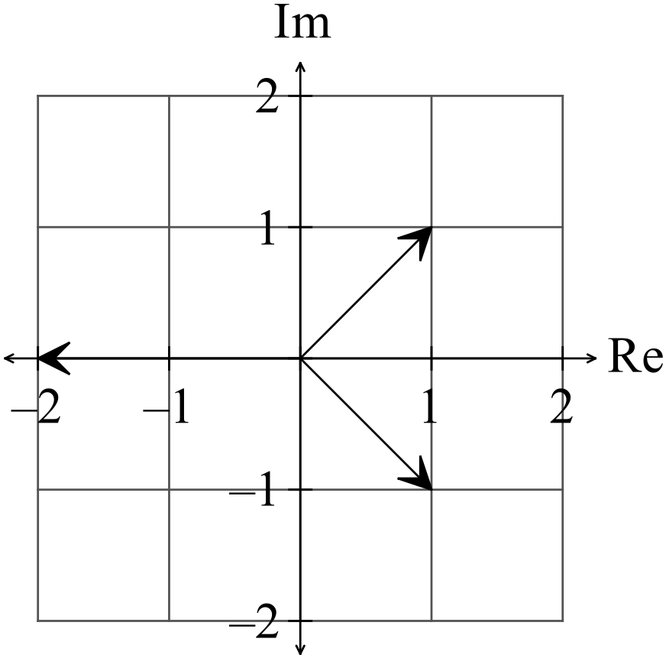 (1)

(ii)

(2)

(d)

OR

(4)

5. (a)
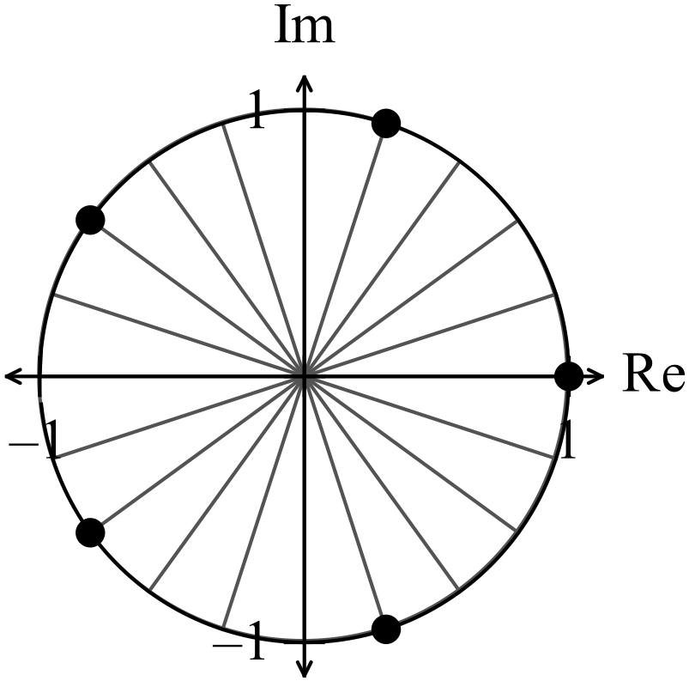

(1)
(b)
-1/error

(3)
6. (a)
-1/error

(3)

(b) is not defined where

(1)
7. (a) (i)

(3)

(ii)

(4)

(b)

(5)

End of Section One solutions.

Calculator−assumed Solutions

8. (a) (2)

(b)

(3)

9. (a) (4)

correct inequalities

(b)

To be wholly real, , (2)

10. (a)

(2)

(b)

(2)

(c)

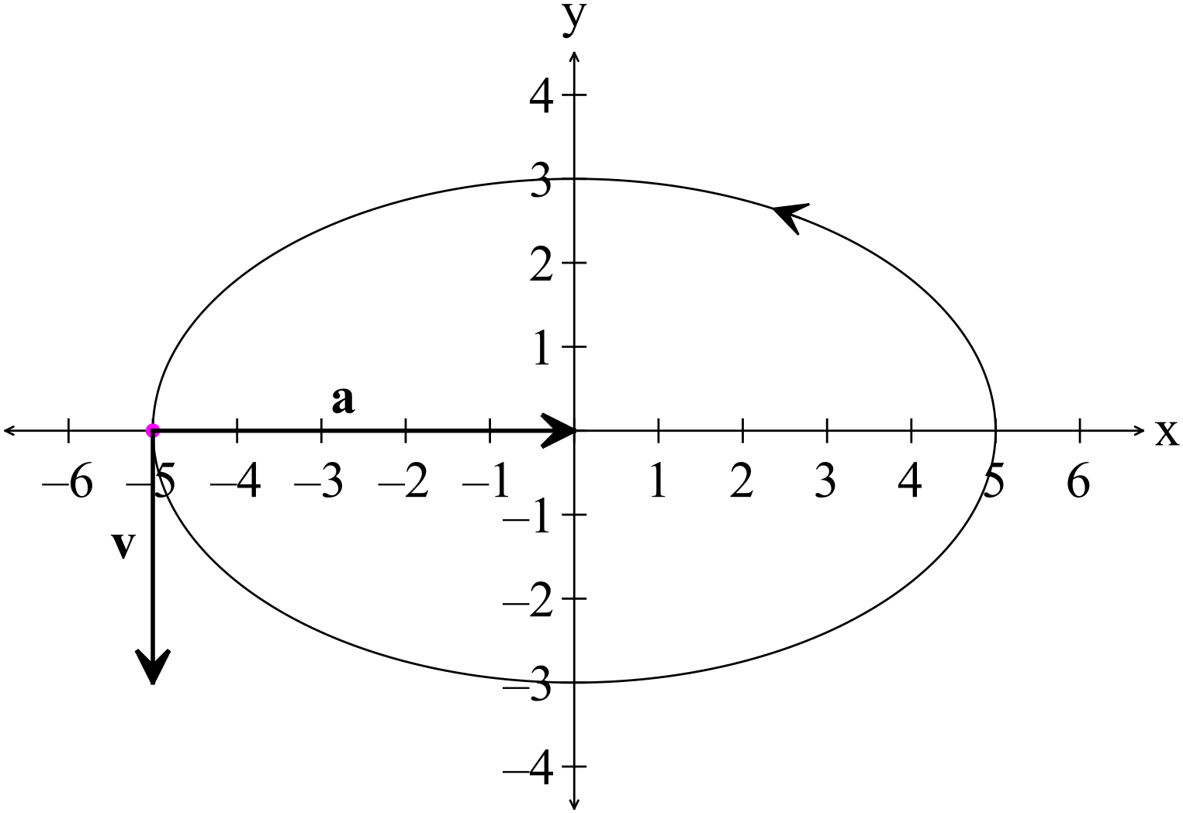 (3)
two vectors

(d)

The next time the direction of travel is perpendicular to the velocity is at (3)

11. (a)
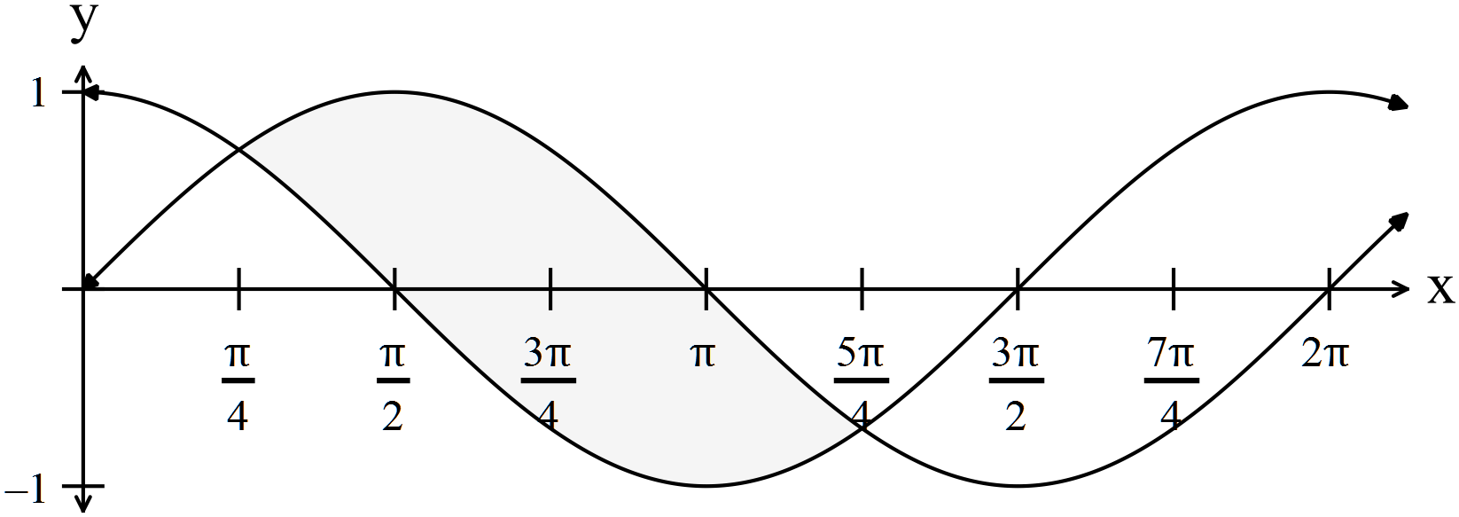

Area = (3)
(b)
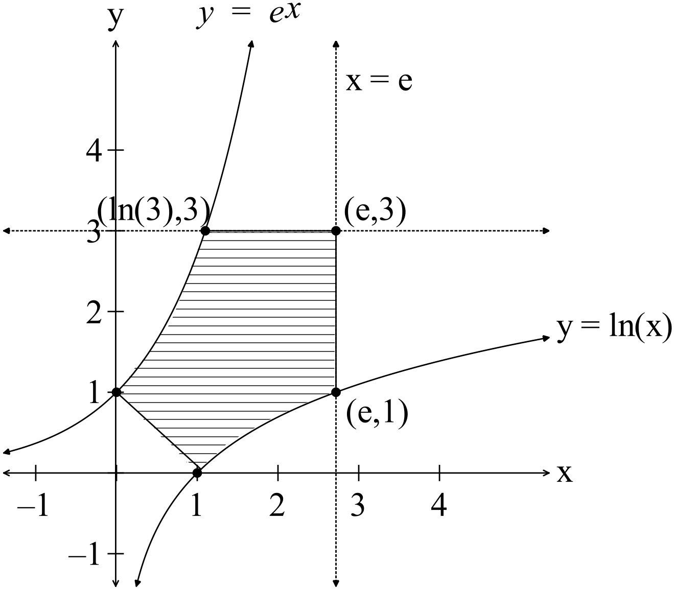

(4)

12. (a)

(3)
(b) (i) Show that

(3)

(ii)

(4)
13. (a)

The maximum speed is
This occurs when

i.e. the displacement from the origin is 0 cm.

(4)
(b) (i)

(2)
(ii)

(1)

(iii)
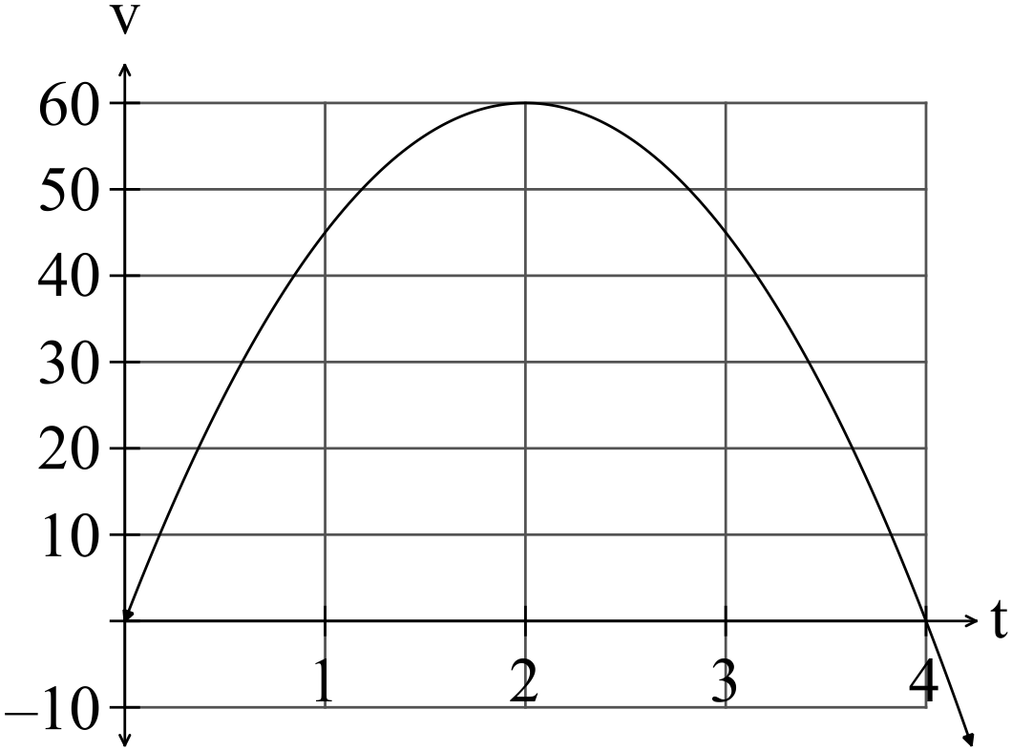

The maximum velocity occurs after two hours.
The maximum speed is 60 km hour^{-1.} (1)

(c)

(5)

14. (a) (i)

(2)
(ii)

(1)

(iii)

NB Any point can be used i.e. can be ANY point. (1)
(b) is a sphere of centre (0,1,-2) with a radius of 3

is a plane
When the plane intersects with the sphere we get a circle equation which is a circle with centre with zero radius, i.e. the intersection is the point . (3)

(c) (i)

On arrival at the nest”
method

The eagle takes 20 seconds to reach the nest. (2)

(ii) OR

The eagle is 60 m from the nest. (3)

(iii) Assume at this time.

At the point of intersection,

Therefore it takes seconds for the eagle to catch the crow.
To determine the position vector:
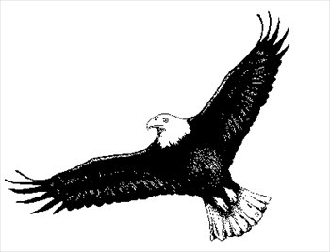

(5)

15. (a) (i) (1)

(ii)
(1)

(iii)

(1)

(iv)
(1) (b) Show that

(4)

16. (a)

(5)
(b) If t = 20 then (2)

17. (a)
(i) 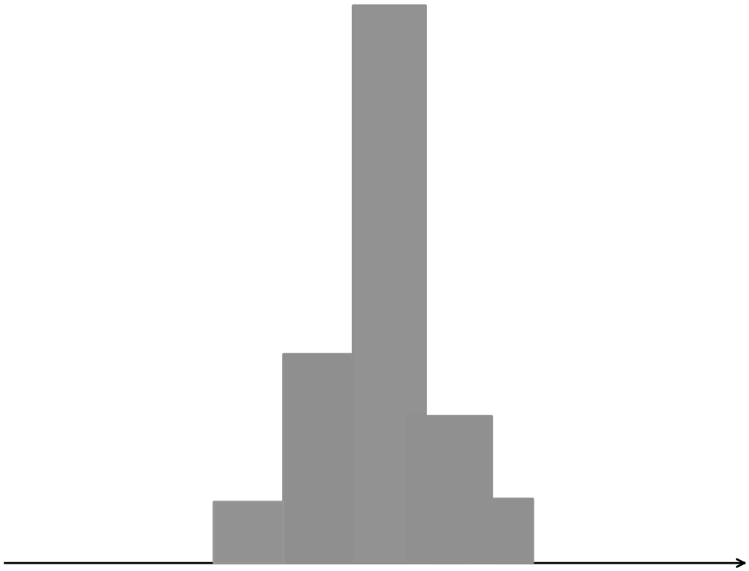 (1)

(ii) The samples will each have a mean not too far from the mean of the population. They will cluster about the population mean hence a tightly clustered (but not necessarily completely symmetrical) histogram is required. (1)

(b) (i) (2)

(ii) (2)

(iii)

(3)

(c)

(3)

(d)

You need a sample size of at least 11 to be 99% confident that the mean of the sample s within 8 grams of the population mean. (5)

End of Section Two

